**Mepco Schlenk Engineering (Autonomous) College**

**Sivakasi**

**Department**

**Of**

**B.E Bio-Medical Engineering**



**19BM551-BIO MEDICAL SENSORS AND INSTRUMENTATION**

**Mini Project**

**Project Title:** *Sleep Inducer using IC 555*

**Faculty in Charge: Submitted By:**

**Dr.M.A.Femina PAUL PRASANNA.L**

Assistant Professor(Sr,grade),  **POORNA NITHIN.R**

Department of BME.

OBJECTIVE:

To design a device to radiate Geo-magnetic field for a deep sleep

ABSTRACT:

Sleep is a natural, active process that is a vital fragment of life and existence. In today’s competitive world mental stress is acute problem .As a result insomnia is occurring all over the world. The lack of restful sleep can affect our ability to carry out daily responsibilities. As a consequence, this can lead to memory problems, depression, irritability and an increased risk of heart disease and automobile related accidents. In most of the cases people use heavy dose drug to get rid of this problem which is very harmful for human body. , We have designed a circuit which creates and radiates an electromagnetic field through a radiator coil that creates an environment which is helpful for sound sleep. So this device generates a magnetic field that mimics the Geo-magnetic field.

INTRODUCTION:

Majority of individuals recall to have slept well in natural atmospheres. The cause for this is that we involuntarily have the capability to perceive Earth’s natural magnetic fields. Sleeping trouble, called insomnia, can comprise of struggle in falling asleep on going to the bed at dark, waking up too quick in the morning as well as waking up regularly through night. Plentiful physical and mental sicknesses have been treated via magnets and the field that it can produce. A concept of enhanced shift from sleeplessness to sleep is suggested to describe the course of insomnia release through static magnetic fields of less strength. A sleep study divulged that a pulse alone can prompt a wave that appears similar to the waves that brain generally creates through sleep . This is harmless for the patient, easy to use by the Handler and offers comfort and relief to the patient. To avoid the side effects of tablets or any strong medication, using this device or model is an efficient and effective way to cope up with the sleep

PRINCIPLE:

The designed model gives out an electromagnetic radiation or field from a solenoid. This works on the principle of **Faraday’s law of electromagnetic induction**. The radiations or field emitted by the electromagnetic coil is a low frequency low strength wave. These waves are similar to the brain waves or sleep waves produced by the brain that induces sleep to a person. The brain picks up these electromagnetic waves generated by the coil and induces an elongated and deep sleep to the person suffering from insomnia. People prefer taking tablets to deal with their Insomnia but they can have some side effects.

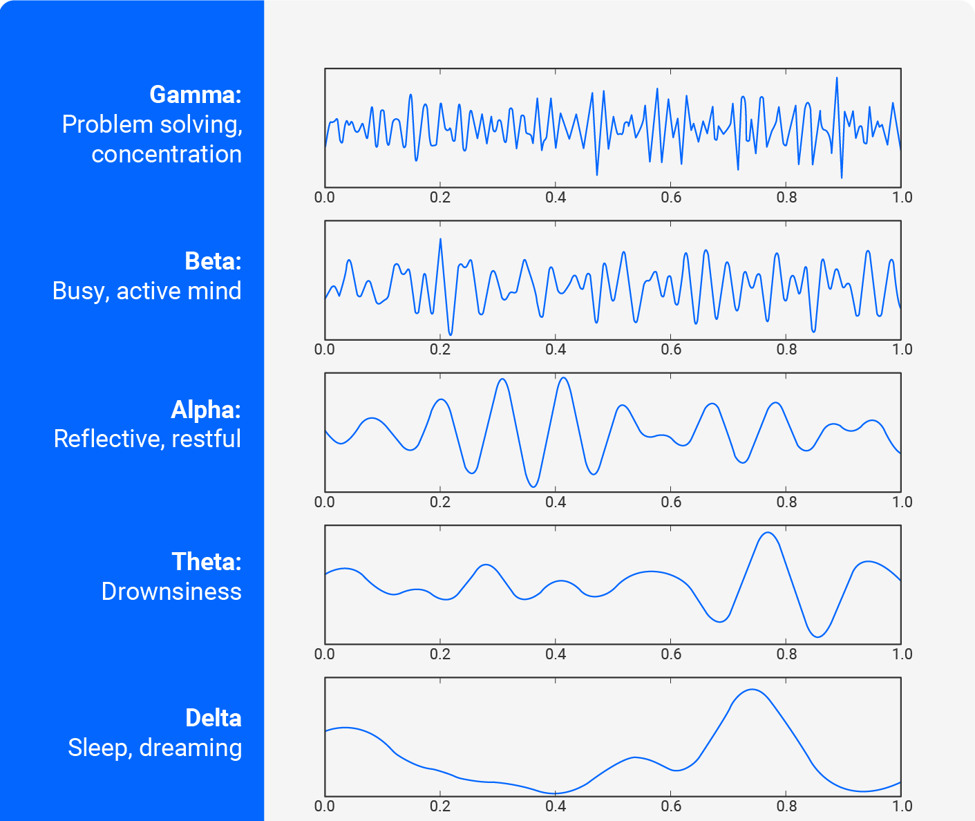

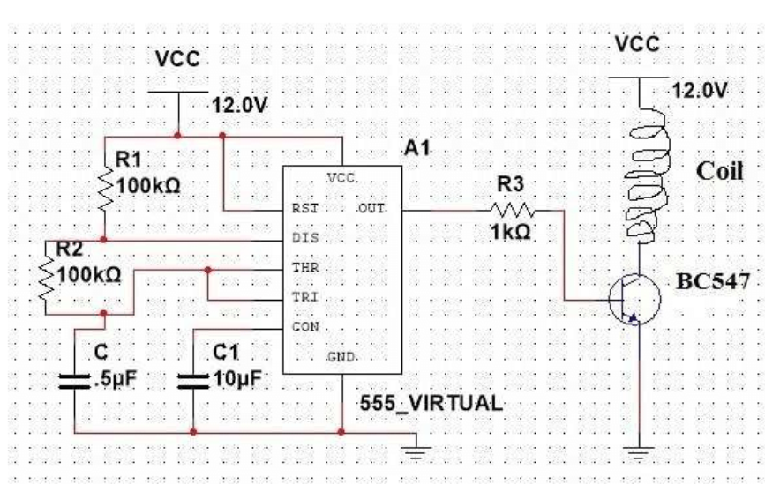 CIRCUIT DIAGRAM:

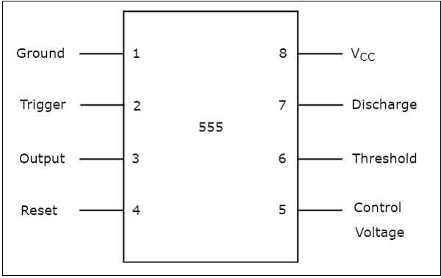IC 555 TIMER:

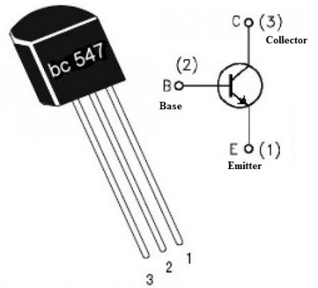BC 547:

WORKING:

The main function of the Biomedical Sleep Inducer System is to produce a ELF (Extra low frequency signal which in turn drive a electromagnet to produce a electromagnetic field of the same frequency.

From the 555 timer we have generated frequency. We have driven this frequency through a coil using transistor BC547. BC547 is an NPN Bipolar Junction Transistor(BJT). A transistor, stands for transfer of resistance, is usually used to amplify current. A tiny low current at its base controls a larger current at collector and emitter terminals. BC547 is especially used for amplification and switching purposes. It is a maximum current gain of 800. The transistor terminals require a set of DC voltage to control within the desired region of its characteristic curves. This is called biasing. For amplification applications, the transistor is biased such it is partly on for all input conditions. The input at base is amplified and brought at the emitter. BC547 is employed in Common Emitter(CE) configuration for amplifiers. The potential divider is that the commonly used

biasing mode. For switching applications, transistor is biased in order that it remains fully on if there is an indication at its base. Within the absence of base signal, it gets completely

off. After we drive this frequency through a coil using transistor BC547, it generates the electromagnetic frequency. When this transistor is fully biased then it can

allow a maximum of 100mA to flow across the collector and emitter. This stage is termed Saturation Region. When base current is removed the transistor becomes fully off, this stage is termed as the Cut-off Region. Using BC547 in this sleep inducer circuit we got a

retardant that the transistor heat up because the current that flows through the collector pin is over than 100mA but less than 150mA. If we replace transistor BC547 to transistor

BD115 then this problem will solved because when the transistor BD115, is fully biased then it can allow a maximum of 150mA to flow across the collector and emitter.

METHODOLOGY:

There are four different factors which affect the brain waves. 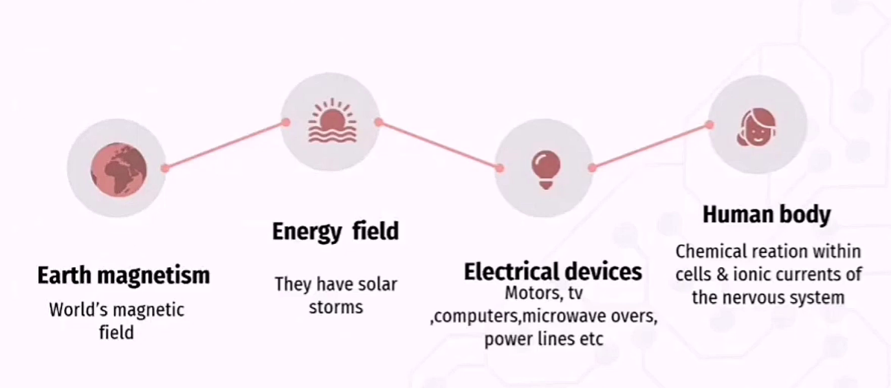 The brain is usually generating a pattern of internal neural frequencies, so called alpha, theta, delta, and beta; names for various ranges of frequencies, plus others, some of

which are altered by the patterns of electromagnetism in our environment. Radio waves, cellular phone microwaves, TV, and general noise from electric circuits also generate

electromagnetic frequencies. The minute electromagnetic patterns of the Earth are also a part of the environment The world is surrounded by magnetic fields: some

generated by the earth's magnetism, others generated by solar storms and changes in weather. Magnetic fields are created by electrical devices (e.g. motors, televisions, office

equipment, computers, microwave ovens, electrical wiring in homes, power lines). Even the human body produces a magnetic fields generated by chemical change within cells

and ionic currents of the nervous system. An electromagnetic field (EMF) is consists of both an electrical and a magnetic flux. The electrical field is because of the presence of

charged particles (such as electrons) and therefore the magnetic flux is because of the movement of the charged particles (such as an electron current). Recently, scientists

discover that external magnetic fields affect the body's functioning in both different ways

|  |  |  |
| --- | --- | --- |
| Capacitor | 2 | 5*10^-6,  10*10^-6 |
| Resistor | 3 | 100k,100k,10k |
| Transistor | 1 | BC 547 |
| Coil | 1 |  |
| IC 555 | 1 |  |
| Battery | 1 | 12v |

COMPONENTS USED:

Application:

* It can be prescribed for the patient suffering from insomnia, hypertension and person wakes early morning and feel difficult to sleep
* This device can be molded and placed under the pillow for a comfort and a better sleeping experience
* By using this device we can reduce the usage of harmful drugs which is often prescribed for sleeping disorder

RESULT:

The Sleep Inducer System helps in fighting insomnia. Apart from this it also supports relaxation, stress management and induces sleep easily without medication. The designed System generates type of geo-magnetic fields and it helps the brain surrounded by an ideal environment for a sound sleep. We should try to get more efficiency and also avoid any kind of adverse effect.

REFERENCES:

* www.researchgate.net
* www.magnetictherapyfacts.org
* S.K.Rits Combining Neural Networks for Protein Secondary Structure

Prediction. IEEE 0-7803-2768-3/95/4.00 0.

* www.therionmagnetics,com/sleep-inducer.html